Maths Overview
Year 2
AUTUMN Term
 | Term 1 |  |  |  |  |  |  | Term 2
 | W 1 | W2 | W 3 | W4 | W 5 | W 6 | W 7 | W1 | W2 | W3 | W 4 | W5 | W 6 | W 7
NC Focus | Number: Place value |  |  |  | Number: Addition and Subtraction |  |  |  |  | Shape |  |  | Measurement Money
NC Objectives | - count in steps of 2, 3, and 5 from 0, and in tens from any number, forward and backward  - recognise the place value of each digit in a two-digit number (tens, ones)  - identify, represent and estimate numbers using different representations, including the number line  - compare and order numbers from 0 up to 100; use <, > and = signs  - read and write numbers to at least 100 in numerals and in words  - use place value and number facts to solve problems. |  |  |  | - solve problems with addition and subtraction:  - using concrete objects and pictorial representations, including those involving numbers, quantities and measures  - applying their increasing knowledge of mental and written methods  - recall and use addition and subtraction facts to 20 fluently, and derive and use related facts up to 100  - add and subtract numbers using concrete objects, pictorial representations, and mentally, including:  - a two-digit number and ones  - a two-digit number and tens  - two two-digit numbers  - adding three one-digit numbers  - show that addition of two numbers can be done in any order (commutative) and subtraction of one number from another cannot  recognise and use the inverse relationship between addition and subtraction and use this to check calculations and solve missing number problems. |  |  |  |  | - identify and describe the properties of 2-D shapes, including the number of sides and line symmetry in a vertical line  - identify and describe the properties of 3-D shapes, including the number of edges, vertices and faces  - identify 2-D shapes on the surface of 3-D shapes [for example, a circle on a cylinder and a triangle on a pyramid]  compare and sort common 2-D and 3-D shapes and everyday objects. |  |  | - recognise and use symbols for pounds (£) and pence (p); combine amounts to make a particular value  - find different combinations of coins that equal the same amounts of money  - solve simple problems in a practical context involving addition and subtraction of money of the same unit, including giving change
Ready to Progress Criteria | - 2NPV–1 Recognise the place value of each digit in two-digit numbers, and compose and decompose two-digit numbers using standard and nonstandard partitioning  - 2NPV–2 Reason about the location of any two digit number in the linear number system, including identifying the previous and next multiple of 10. |  |  |  | - 2NF–1 Secure fluency in addition and subtraction facts within 10, through continued practice.  - 2AS–1 Add and subtract across 10.  - 2AS–2 Recognise the subtraction structure of ‘difference’ and answer questions of the form, “How many more…?”.  - 2AS–3 Add and subtract within 100 by applying related one-digit addition and subtraction facts: add and subtract only ones or only tens to/from a two digit number.  - 2AS–4 Add and subtract within 100 by applying related one-digit addition and subtraction facts: add and subtract any 2 two digit numbers. |  |  |  |  | - 2G–1 Use precise language to describe the properties of 2D and 3D shapes, and compare shapes by reasoning about similarities and differences in properties. |  |  | 2NPV–2 Reason about the location of any two digit number in the linear number system, including identifying the previous and next multiple of 10.
White Rose Small Steps | 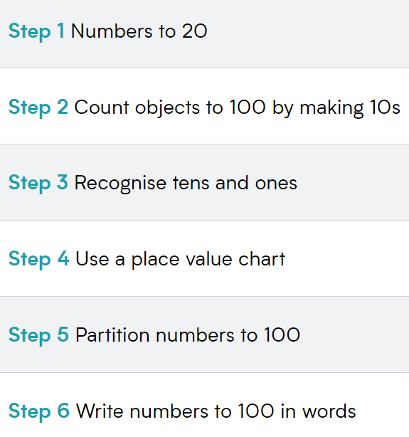  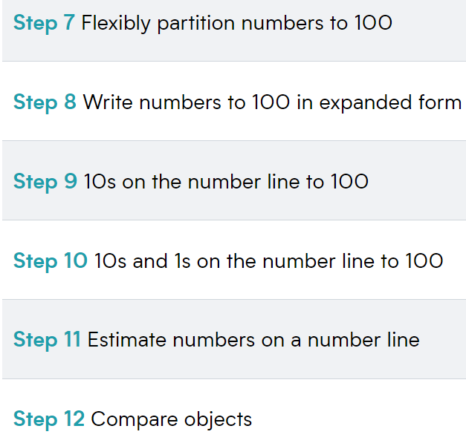  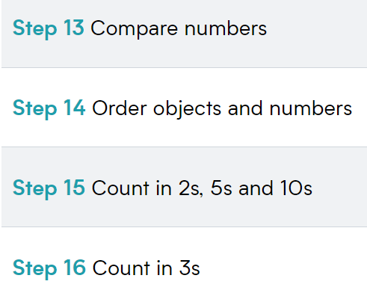 |  |  |  | - 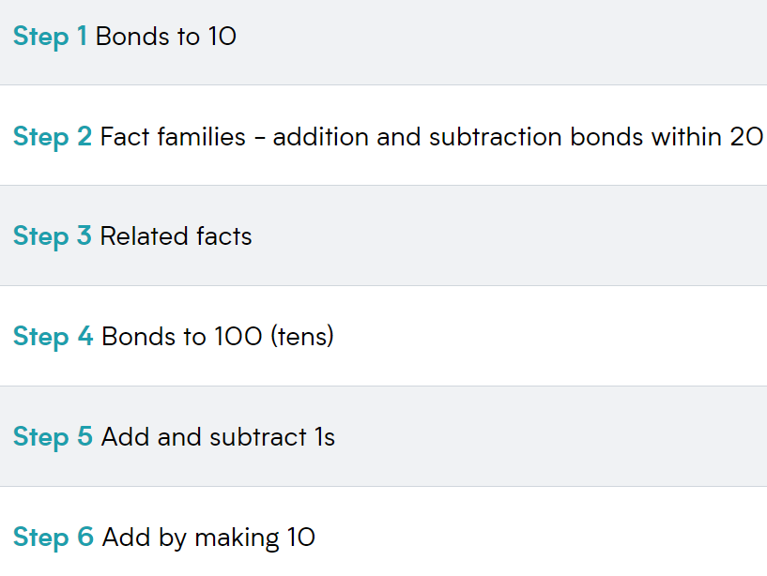  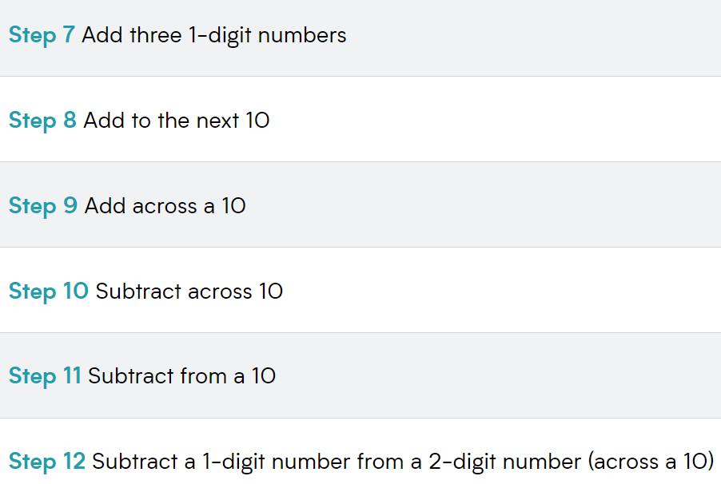  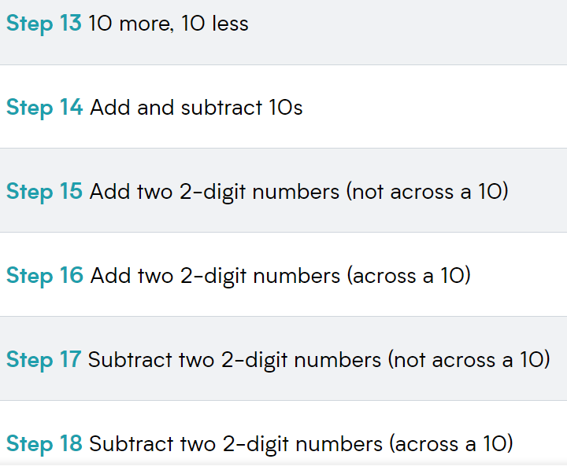  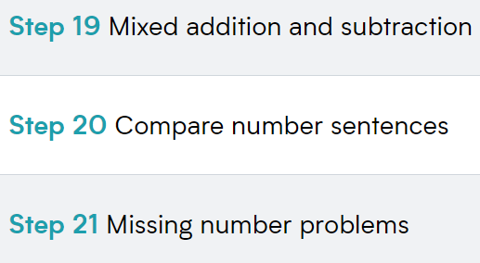 |  |  |  |  | 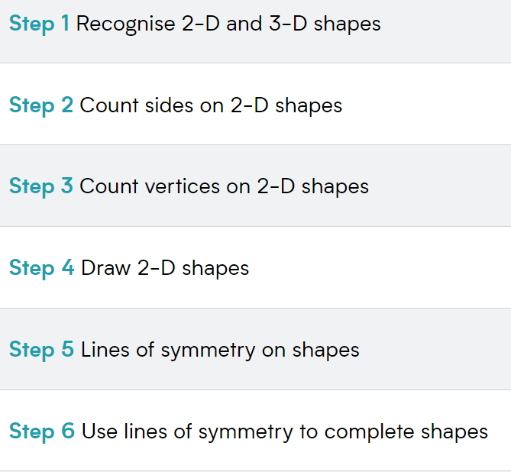  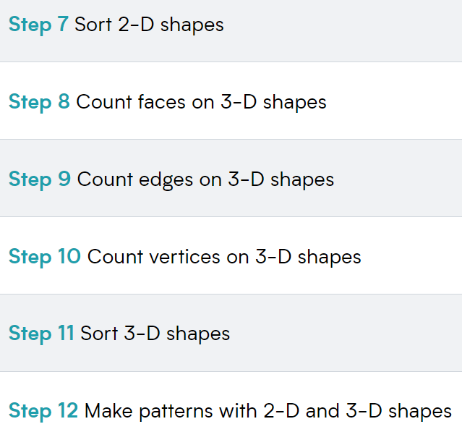 |  |  | 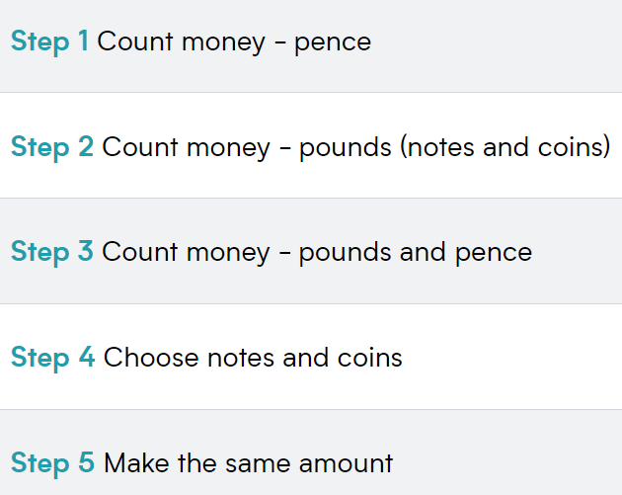  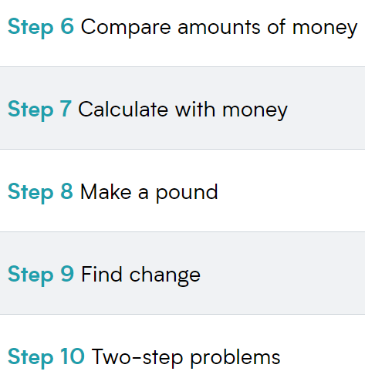
Year 1 Revisit
(potential gaps in learning from previous year)

Consolidation Required
(based on current End of Block Assessments)

Maths Overview
Year 2
SPRING Term
 | Term 3 |  |  |  |  |  |  | Term 4
 | W 1 | W 2 | W 3 | W4 | W5 | W6 | W 7 | W 1 | W2 | W 3 | W 4 | W5 | W 6
NC Focus | Measurement Money cont. | Number: Multiplication and Division |  |  |  |  |  | Measurement: Length and Height |  | Measurement: Mass, Capacity and Temperature |  |  | Consolidation
NC Objectives | - recognise and use symbols for pounds (£) and pence (p); combine amounts to make a particular value  - find different combinations of coins that equal the same amounts of money  - solve simple problems in a practical context involving addition and subtraction of money of the same unit, including giving change | - recall and use multiplication and division facts for the 2, 5 and 10 multiplication tables, including recognising odd and even numbers  - calculate mathematical statements for multiplication and division within the multiplication tables and write them using the multiplication (×), division (÷) and equals (=) signs  - show that multiplication of two numbers can be done in any order (commutative) and division of one number by another cannot  solve problems involving multiplication and division, using materials, arrays, repeated addition, mental methods, and multiplication and division facts, including problems in contexts. |  |  |  |  |  | - choose and use appropriate standard units to estimate and measure length/height in any direction (m/cm) to the nearest appropriate unit, using rulers.  - compare and order lengths, and record the results using >, < and = |  | - choose and use appropriate standard units to estimate and measure mass (kg/g); temperature (°C); capacity (litres/ml) to the nearest appropriate unit, using scales, thermometers and measuring vessels  - compare and order mass, volume/capacity and record the results using >, < and =
Ready to Progress Criteria | 2NPV–2 Reason about the location of any two digit number in the linear number system, including identifying the previous and next multiple of 10. | - 2MD–1 Recognise repeated addition contexts, representing them with multiplication equations and calculating the product, within the 2, 5 and 10 multiplication tables.  - 2MD–2 Relate grouping problems where the number of groups is unknown to multiplication equations with a missing factor, and to division equations (quotitive division). |  |  |  |  |  | - 2NPV–1 Recognise the place value of each digit in two-digit numbers, and compose and decompose two-digit numbers using standard and nonstandard partitioning  - 2NPV–2 Reason about the location of any twodigit number in the linear number system, including identifying the previous and next multiple of 10. |  | - 2MD–1 Recognise repeated addition contexts, representing them with multiplication equations and calculating the product, within the 2, 5 and 10 multiplication tables
White Rose Small Steps |  | 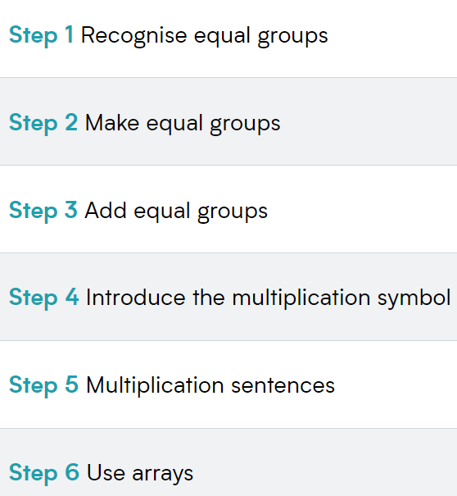  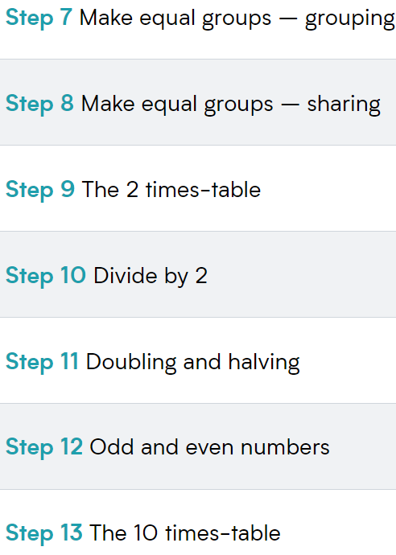  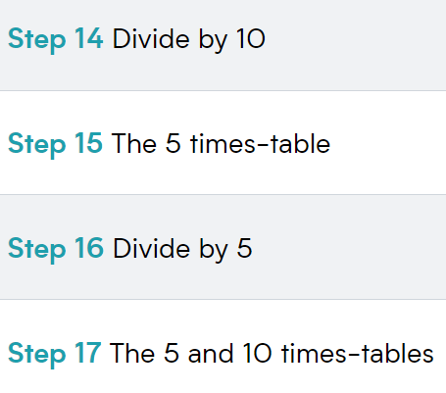 |  |  |  |  |  | 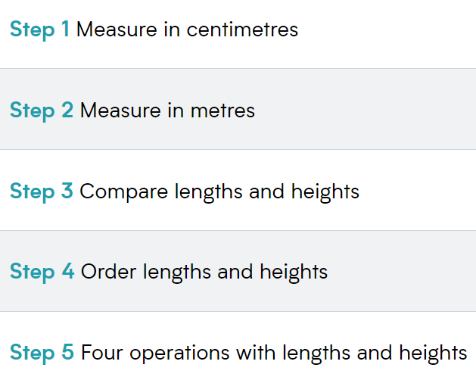 |  | 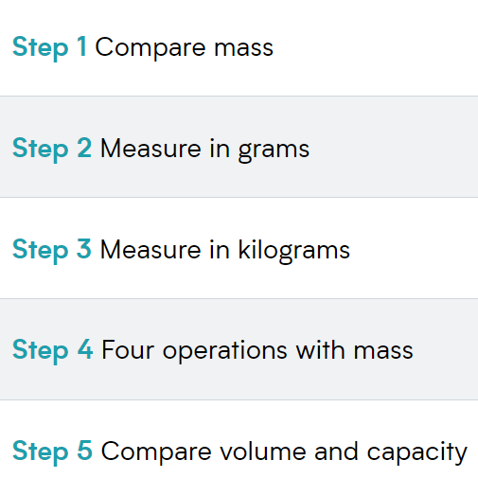  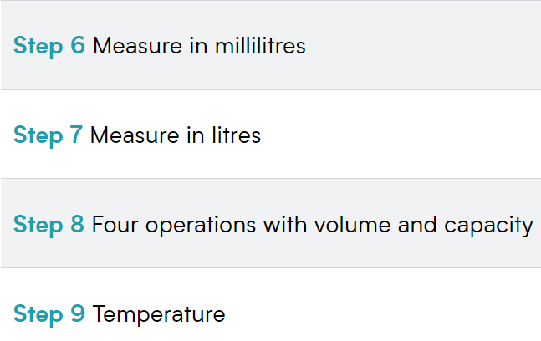
Year 1 Revisit
(potential gaps in learning from previous year)

Consolidation Required
(based on current End of Block Assessments)

Maths Overview
Year
SUMMER Term
 | Term 5 |  |  |  |  |  |  |  | Term 6
 | W 1 | W2 | W3 | W4 | W5 | W6 |  |  |  | W 1 | W2 | W 3 | W4 | W5 | W6 | W 7  (3 days)
NC Focus | Statistics |  | Number: Fractions |  |  | Consolidation  and  Assessment |  |  |  | Position and Direction |  | Measurement: Time |  |  | Problem solving and efficient methods
NC Objectives | - interpret and construct simple pictograms, tally charts, block diagrams and simple tables  - ask and answer simple questions by counting the number of objects in each category and sorting the categories by quantity  - ask and answer questions about totalling and comparing categorical data. |  | - recognise, find, name and write fractions , , and of a length, shape, set of objects or quantity  - write simple fractions for example, of 6 = 3 and recognise the equivalence of and . |  |  |  |  |  |  | - order and arrange combinations of mathematical objects in patterns and sequences  use mathematical vocabulary to describe position, direction and movement, including movement in a straight line and distinguishing between rotation as a turn and in terms of right angles for quarter, half and three-quarter turns (clockwise and anti-clockwise). |  | - compare and sequence intervals of time  - tell and write the time to five minutes, including quarter past/to the hour and draw the hands on a clock face to show these times  - know the number of minutes in an hour and the number of hours in a day. |  |  | - use place value and number facts to solve problems.  - recognise and use the inverse relationship between addition and subtraction and use this to check calculations and solve missing number problems.  - solve problems involving multiplication and division, using materials, arrays, repeated addition, mental methods, and multiplication and division
Ready to Progress Criteria | - 2MD–1 Recognise repeated addition contexts, representing them with multiplication equations and calculating the product, within the 2, 5 and 10 multiplication tables.  - 2MD–2 Relate grouping problems where the number of groups is unknown to multiplication equations with a missing factor, and to division equations (quotitive division).
White Rose Small Steps
Year 1 Revisit
(potential gaps in learning from previous year)

Consolidation Required
(based on current End of Block Assessments and teaching)

